**Lab Report-03**

|  |  |
| --- | --- |
| **Course Code:** | **Course Title:** |
| CSE 416 | Web Engineering Lab |

|  |  |
| --- | --- |
| **Lab Report Details** | |
| Lab Perform Date | : 02/06/2025 |
| Report Submission Date | : 09/06/2025 |

|  |  |  |
| --- | --- | --- |
| **Submitted To** | **Submitted By** | |
| **Ms. Nishat Sadaf Lira**  Lecturer  Department of CSE  Daffodil International University. | Name  SID  Section  Daffodil | : Munna Biswas  : 221-15-5261  : 61-J2  International University |
|  | |

**Experiment No: 03**

**Experiment Name:** Interactive Web Page Development Using JavaScript.

**Objective:**

To enhance a web page with interactive JavaScript features, including event handling, DOM manipulation, dynamic content updates, and user interface improvements, making the page responsive to user actions.

**JavaScript Operations Performed:**

| **No.** | **Feature Name** | **Description** | **Key Methods/Functions Used** |
| --- | --- | --- | --- |
| 1 | Live Clock Display | Shows the current time in the header and updates every second. | setInterval(), Date() |
| 2 | Buy Now Button with Cart | Increments cart count and shows an alert when an item is purchased. | onclick, innerText |
| 3 | Search Filter | Filters coffee items dynamically based on search input. | keyup, querySelectorAll |
| 4 | Dark Mode Toggle | Switches between light and dark themes for the website. | classList.toggle() |

**Code Snippets and Outcomes:**

**1. Live Clock Display**

**Description:**

Displays the current time in the header and updates every second.

**Code Snippet:**

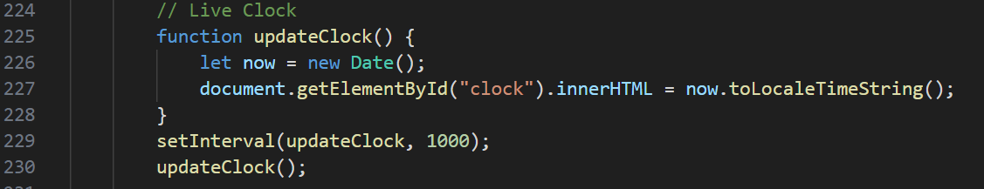

**Screenshot:**



**2. Buy Now Button with Cart Counter**

**Description:**

Each "Buy Now" button adds an item to the cart and updates the counter in the header.

**Code Snippet:**

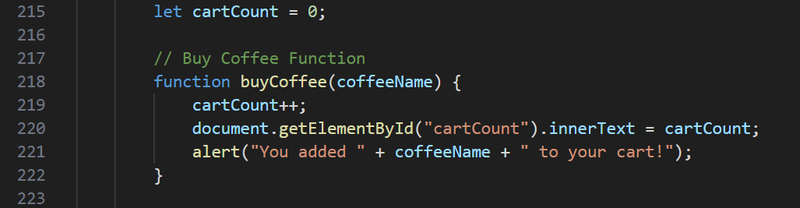

**Screenshot:**

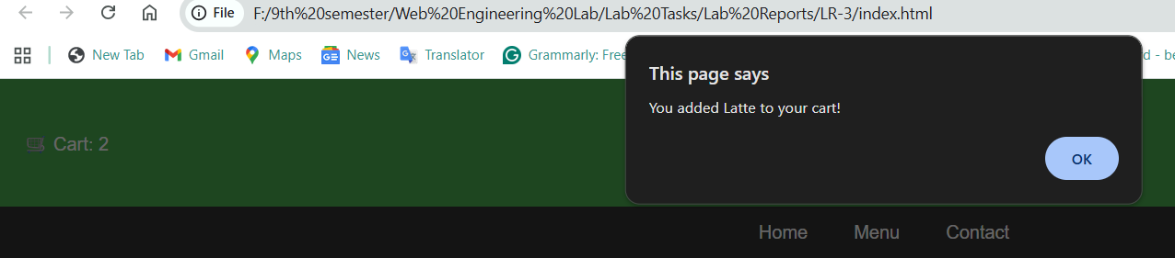

**3. Search Filter for Coffee Menu**

**Description:**

Filters coffee items dynamically based on user input in the search bar.

**Code Snippet:**

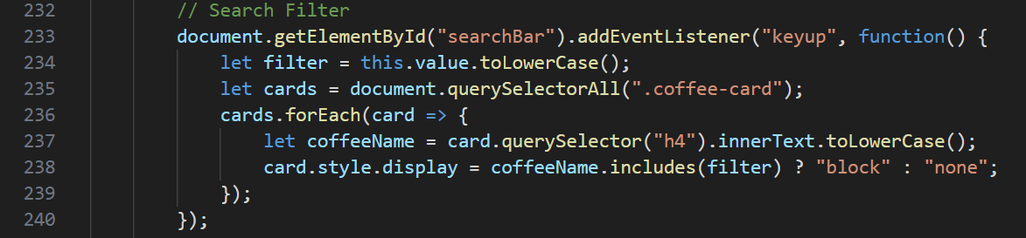

**Screenshot:**

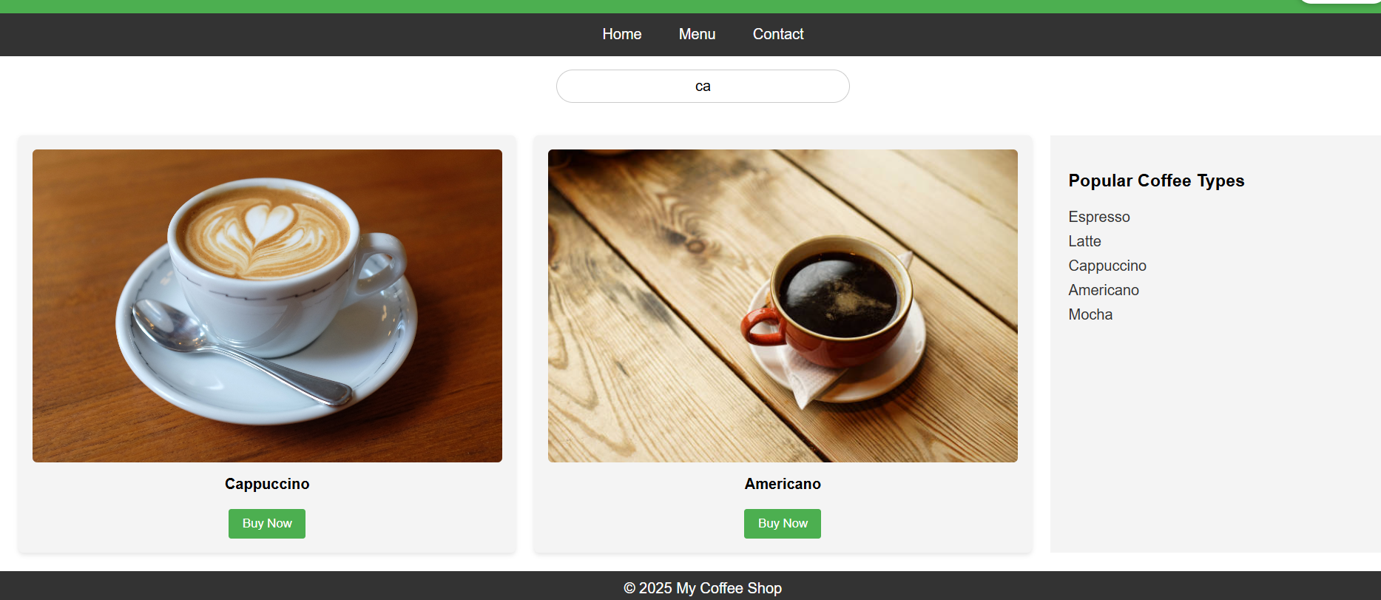

**4. Dark Mode Toggle**

**Description:**Toggles the entire website’s theme between light and dark mode when the user clicks a button.

**Code Snippet:**

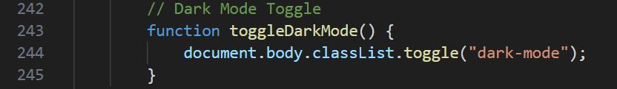

**Screenshot:**

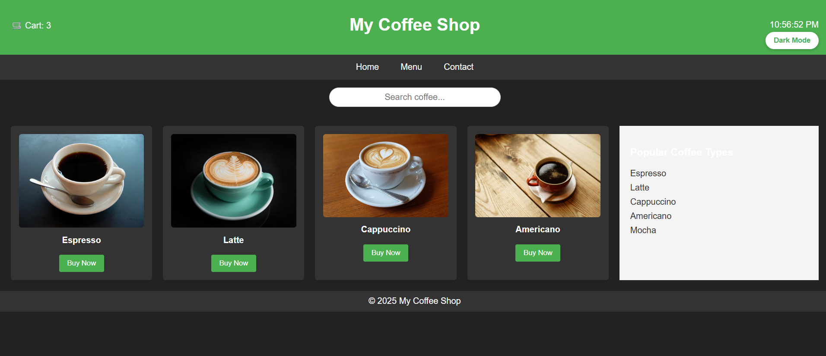

**Final Output:**

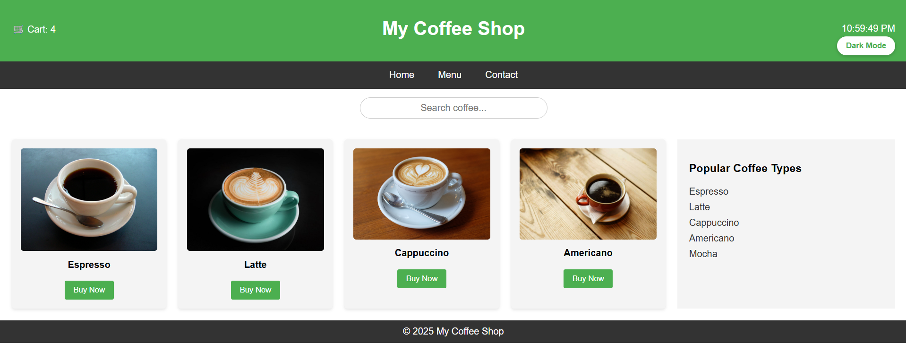

**Outcome:**

By implementing these features, the coffee shop website became interactive and user-friendly. JavaScript enabled real-time updates, search filtering, theme switching, and engaging hover animations, improving both functionality and user experience.

**Conclusion:**

JavaScript allows web pages to respond dynamically to user interactions, making them engaging and practical. Features such as live clocks, search filtering, dark mode, and event-driven actions contribute to better usability and modern web design.

**References:**

<https://developer.mozilla.org/en-US/docs/Web/JavaScript>

<https://www.w3schools.com/js/>

<https://javascript.info/>